[E118] Weight sensor+Weight sensor PCB

Remove the heat insulations.

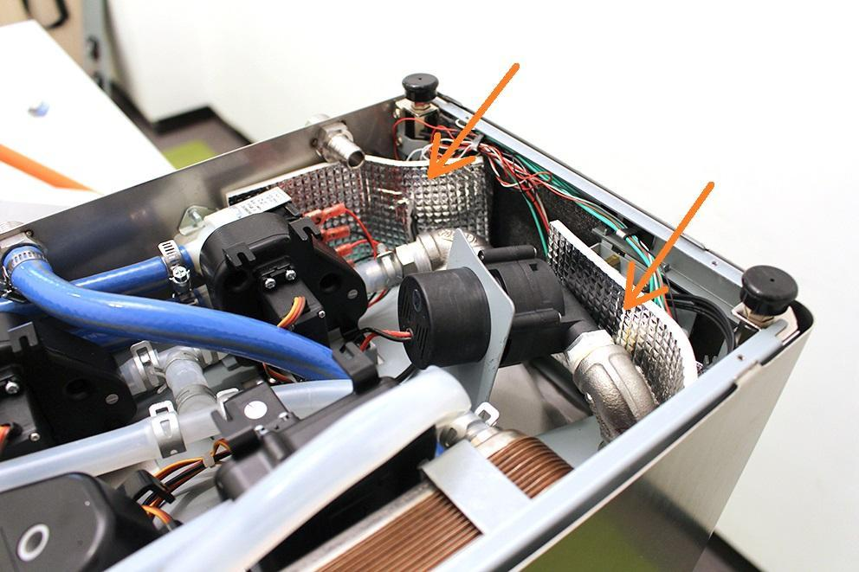

Remove the wort outlet hose clamp and silicone tube from the fitting. Bend the silicone tube away in order to easier assembling.

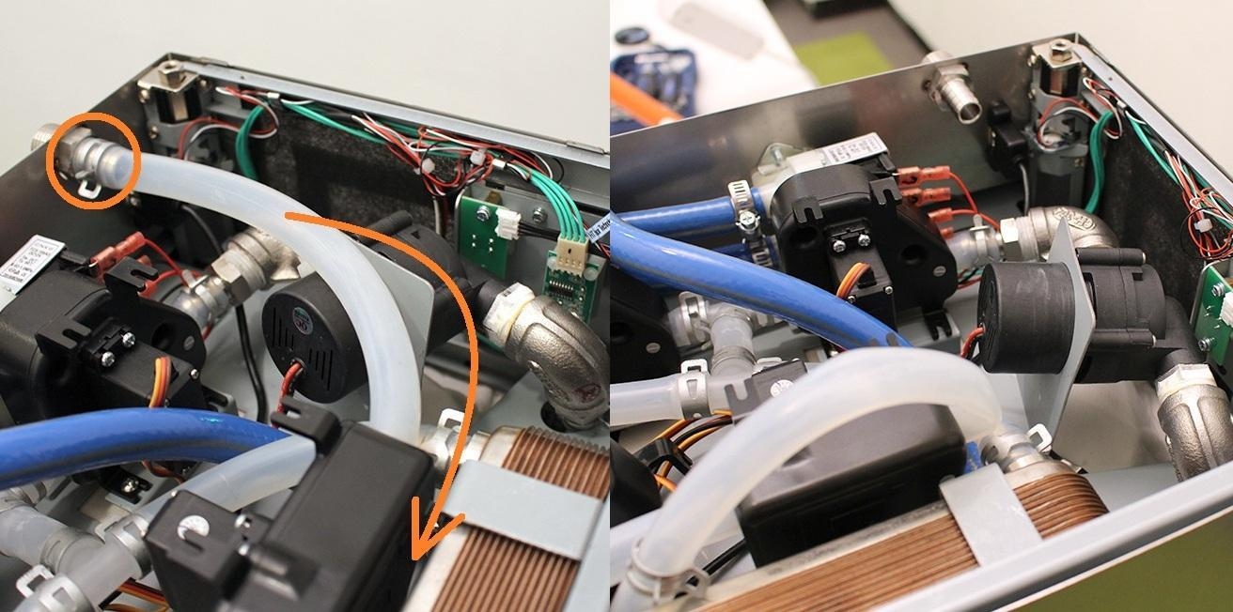

Pull off the pipe clamp from the encircled fitting. Pull off the silicone hose from the fitting.

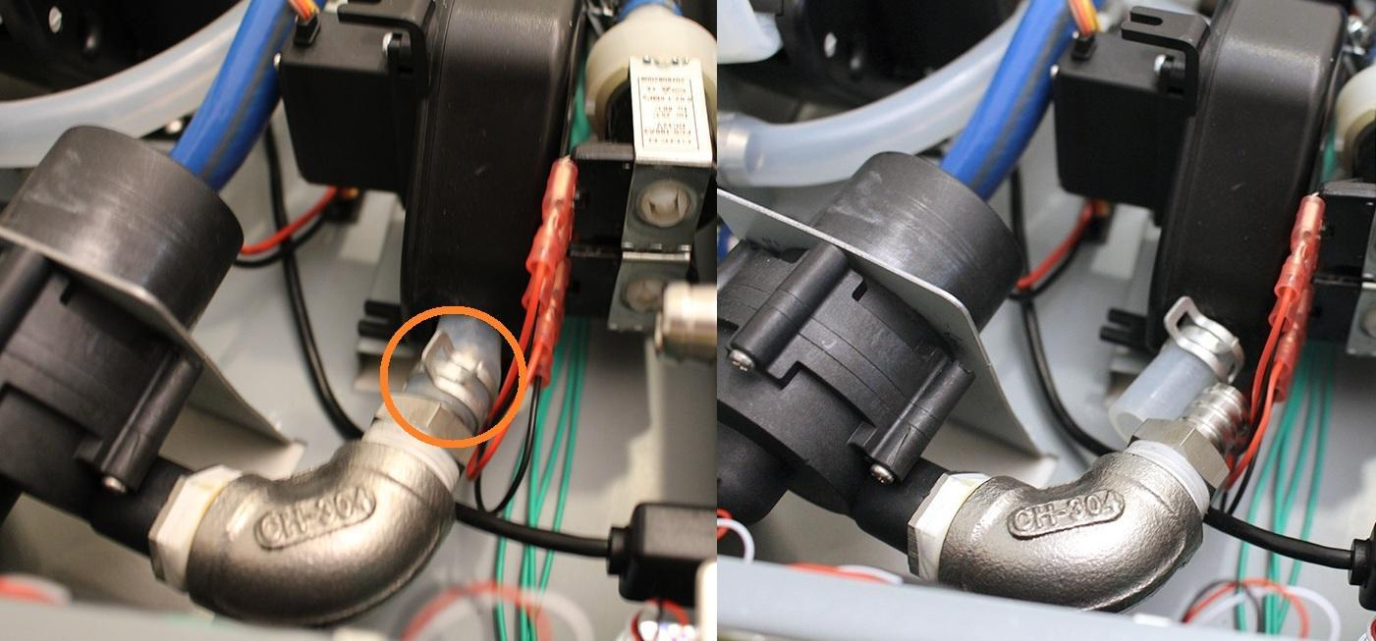

While you keep the indicated hose clamp tightly, you can pull off the pump from the silicone tube by rotating the pump around its axis.

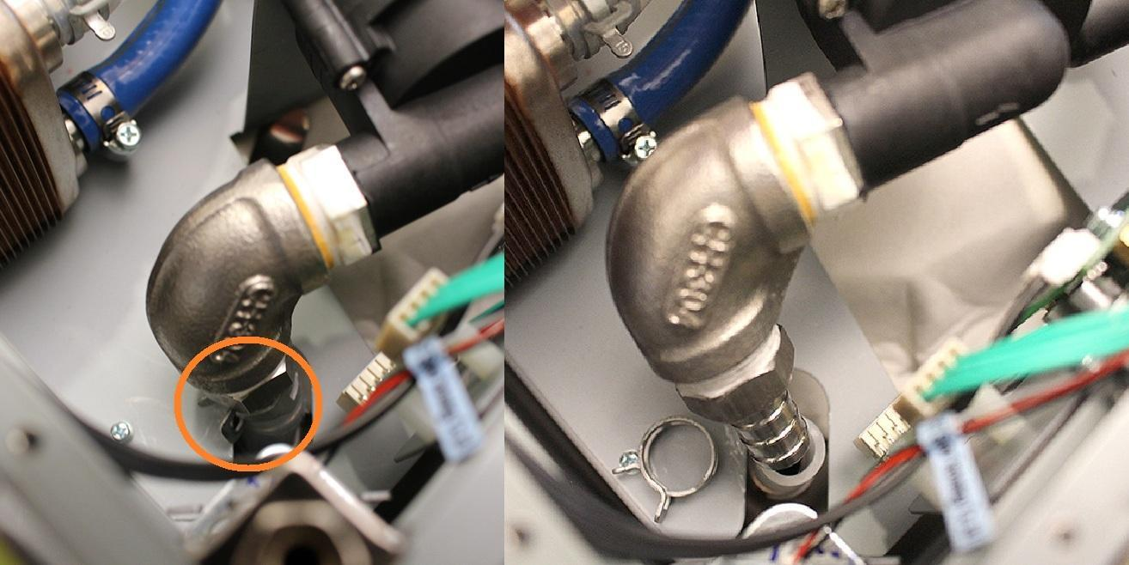

Bend the pump holder sheetmetal carefully in order to the easier pump removing.

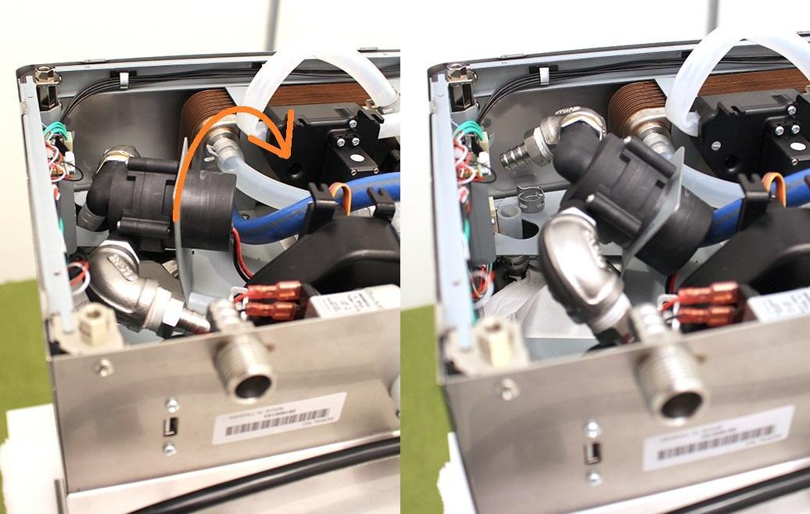

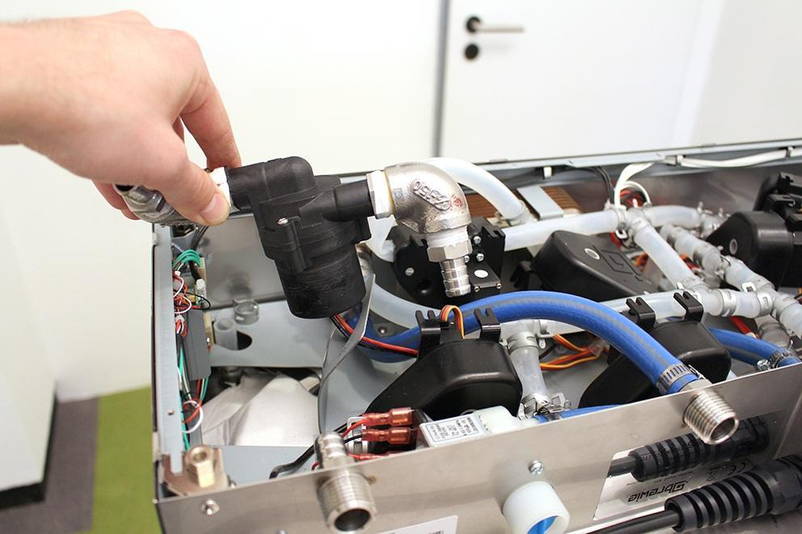

Screw in a machine foot into the hexagon part, it will help with the further assembling. Unscrew the indicated screw.

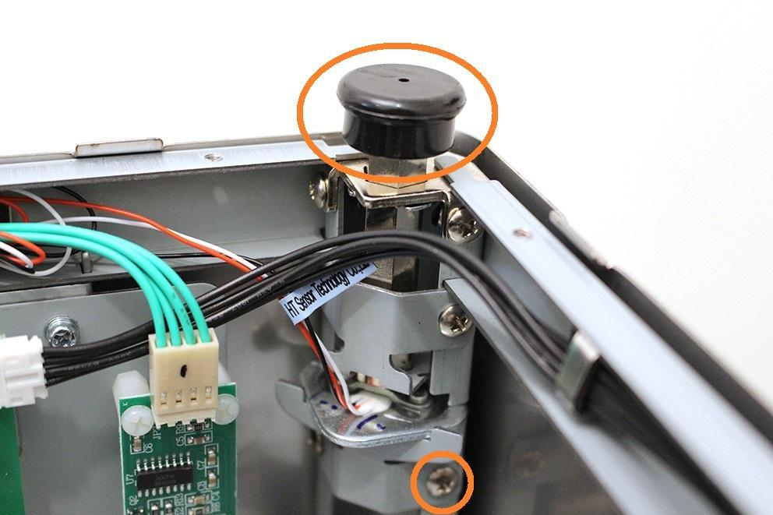

Bend carefully the weight sensor holder sheetmetal.

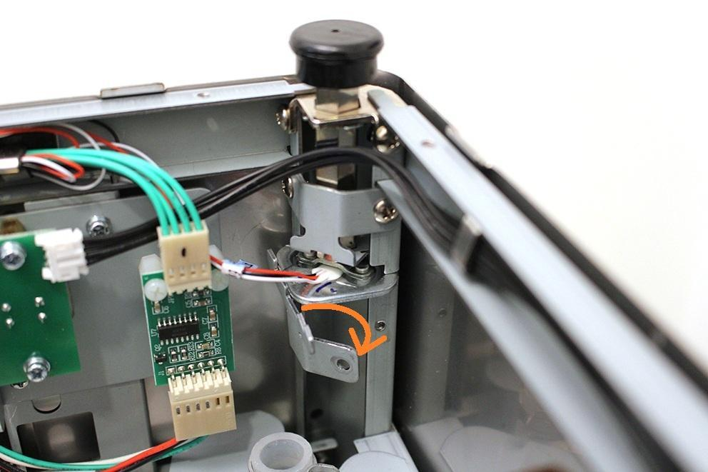

Now you can remove the weight sensor.

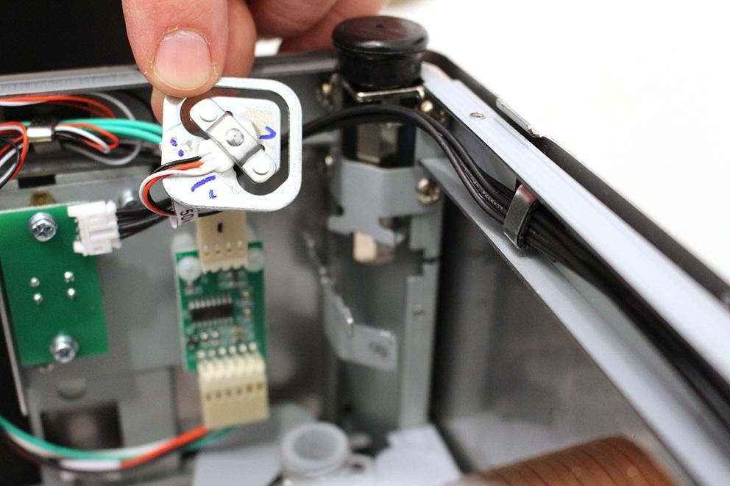

Screw in a machine foot into the hexagon part, it will help with the further assembling. Unscrew the indicated screw.

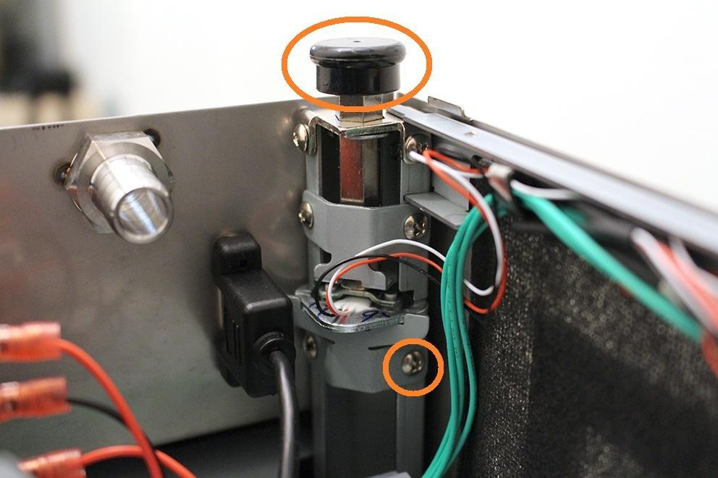

Bend carefully the weight sensor holder sheetmetal.

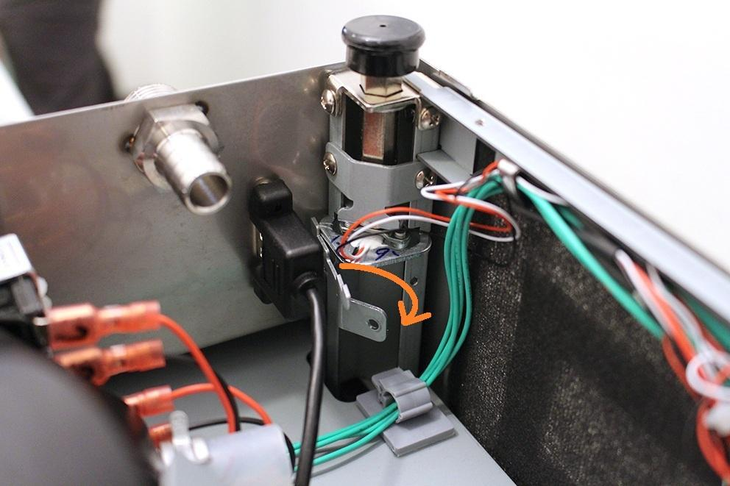

Now you can remove the weight sensor.

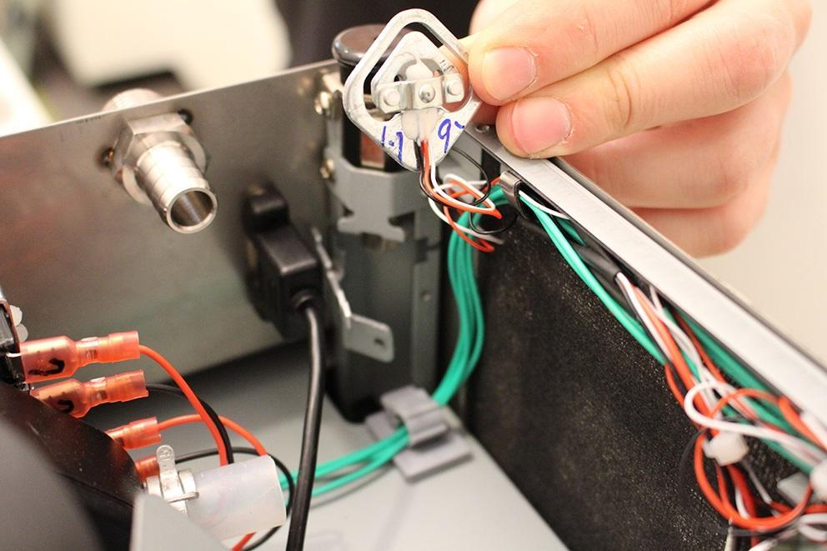

Disconnect the indicated plugs.

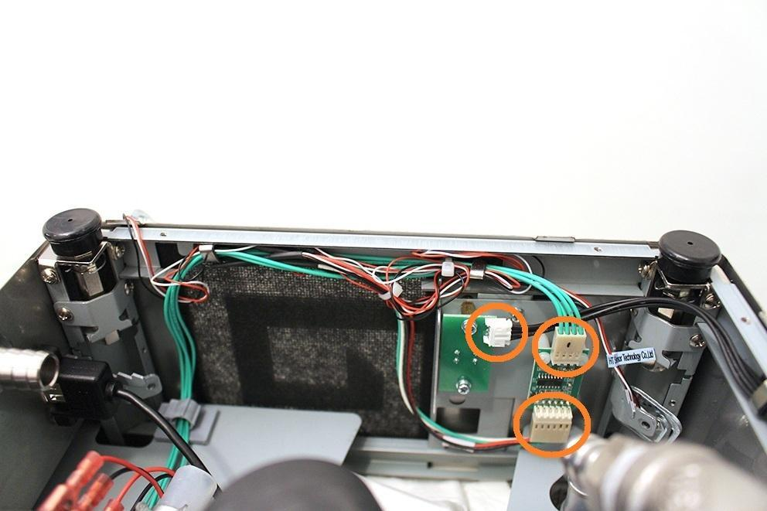

Remove the cables from the clamps.

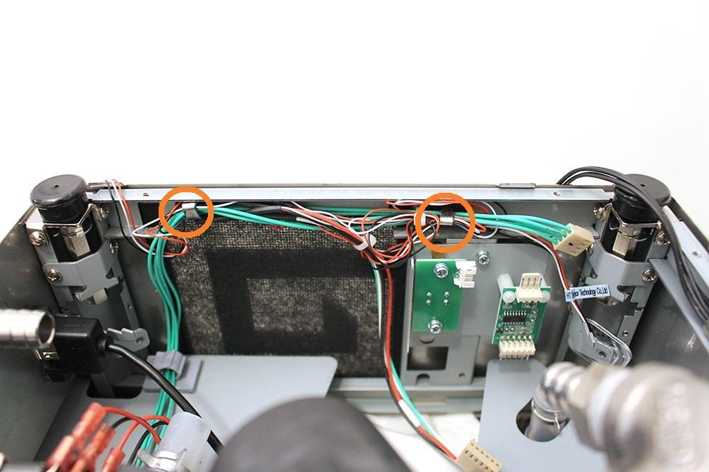

Now you can remove both of the weight sensors.

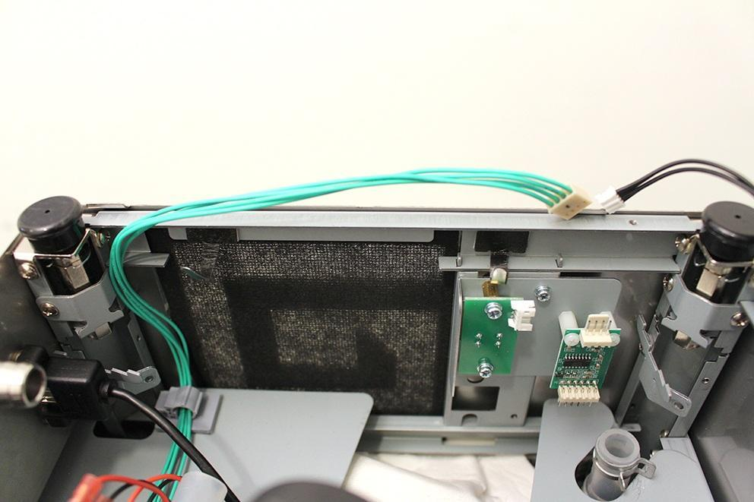

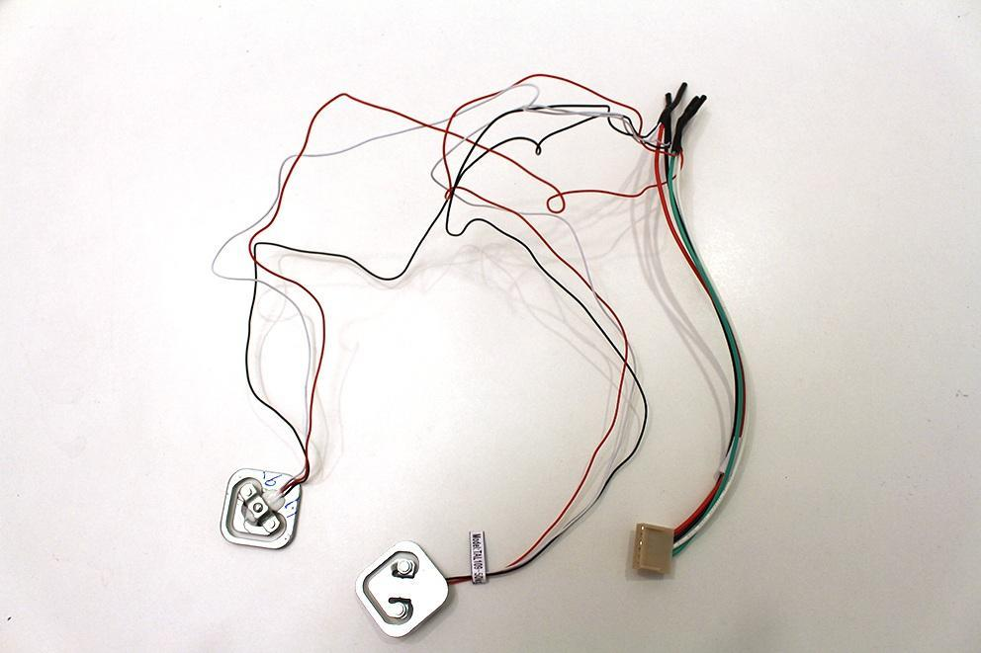

Replace the weight sensors.

Unscrew the indicated screws.

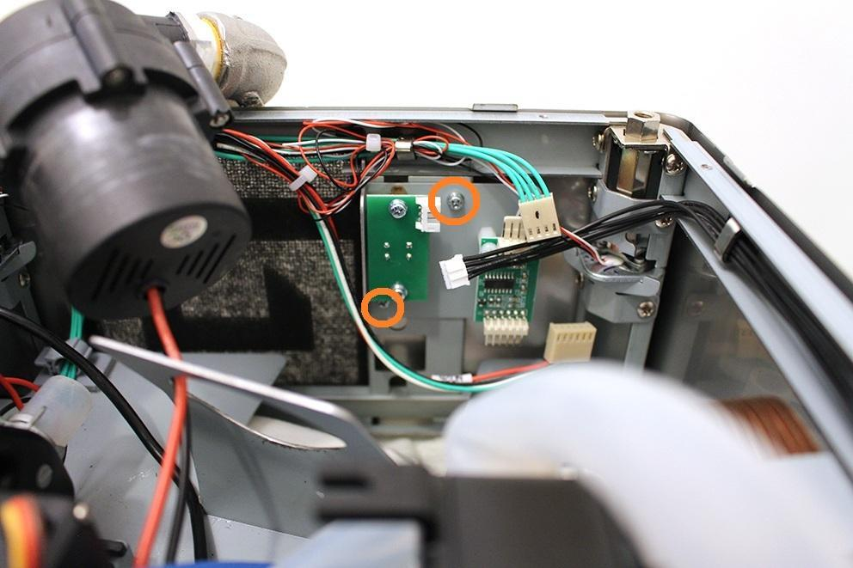

The weight sensor PCBA can be found at the place shown below.

This is the old version of the weight sensor PCBA in the picture. Maybe you will find the new version in the serviced machine. Whatever you find, please replace this part with a new one.

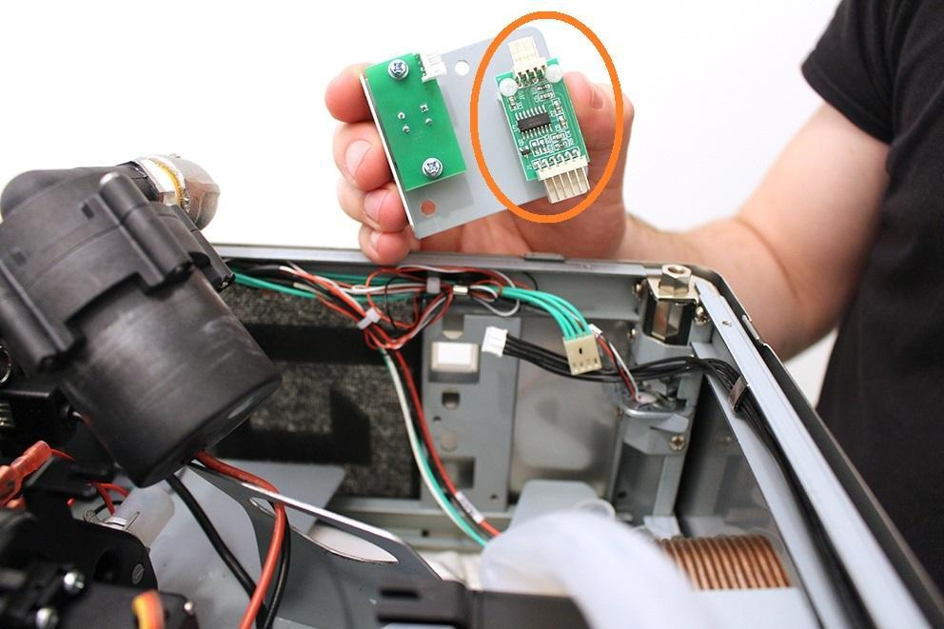

This is the new version of the weight sensor PCBA.

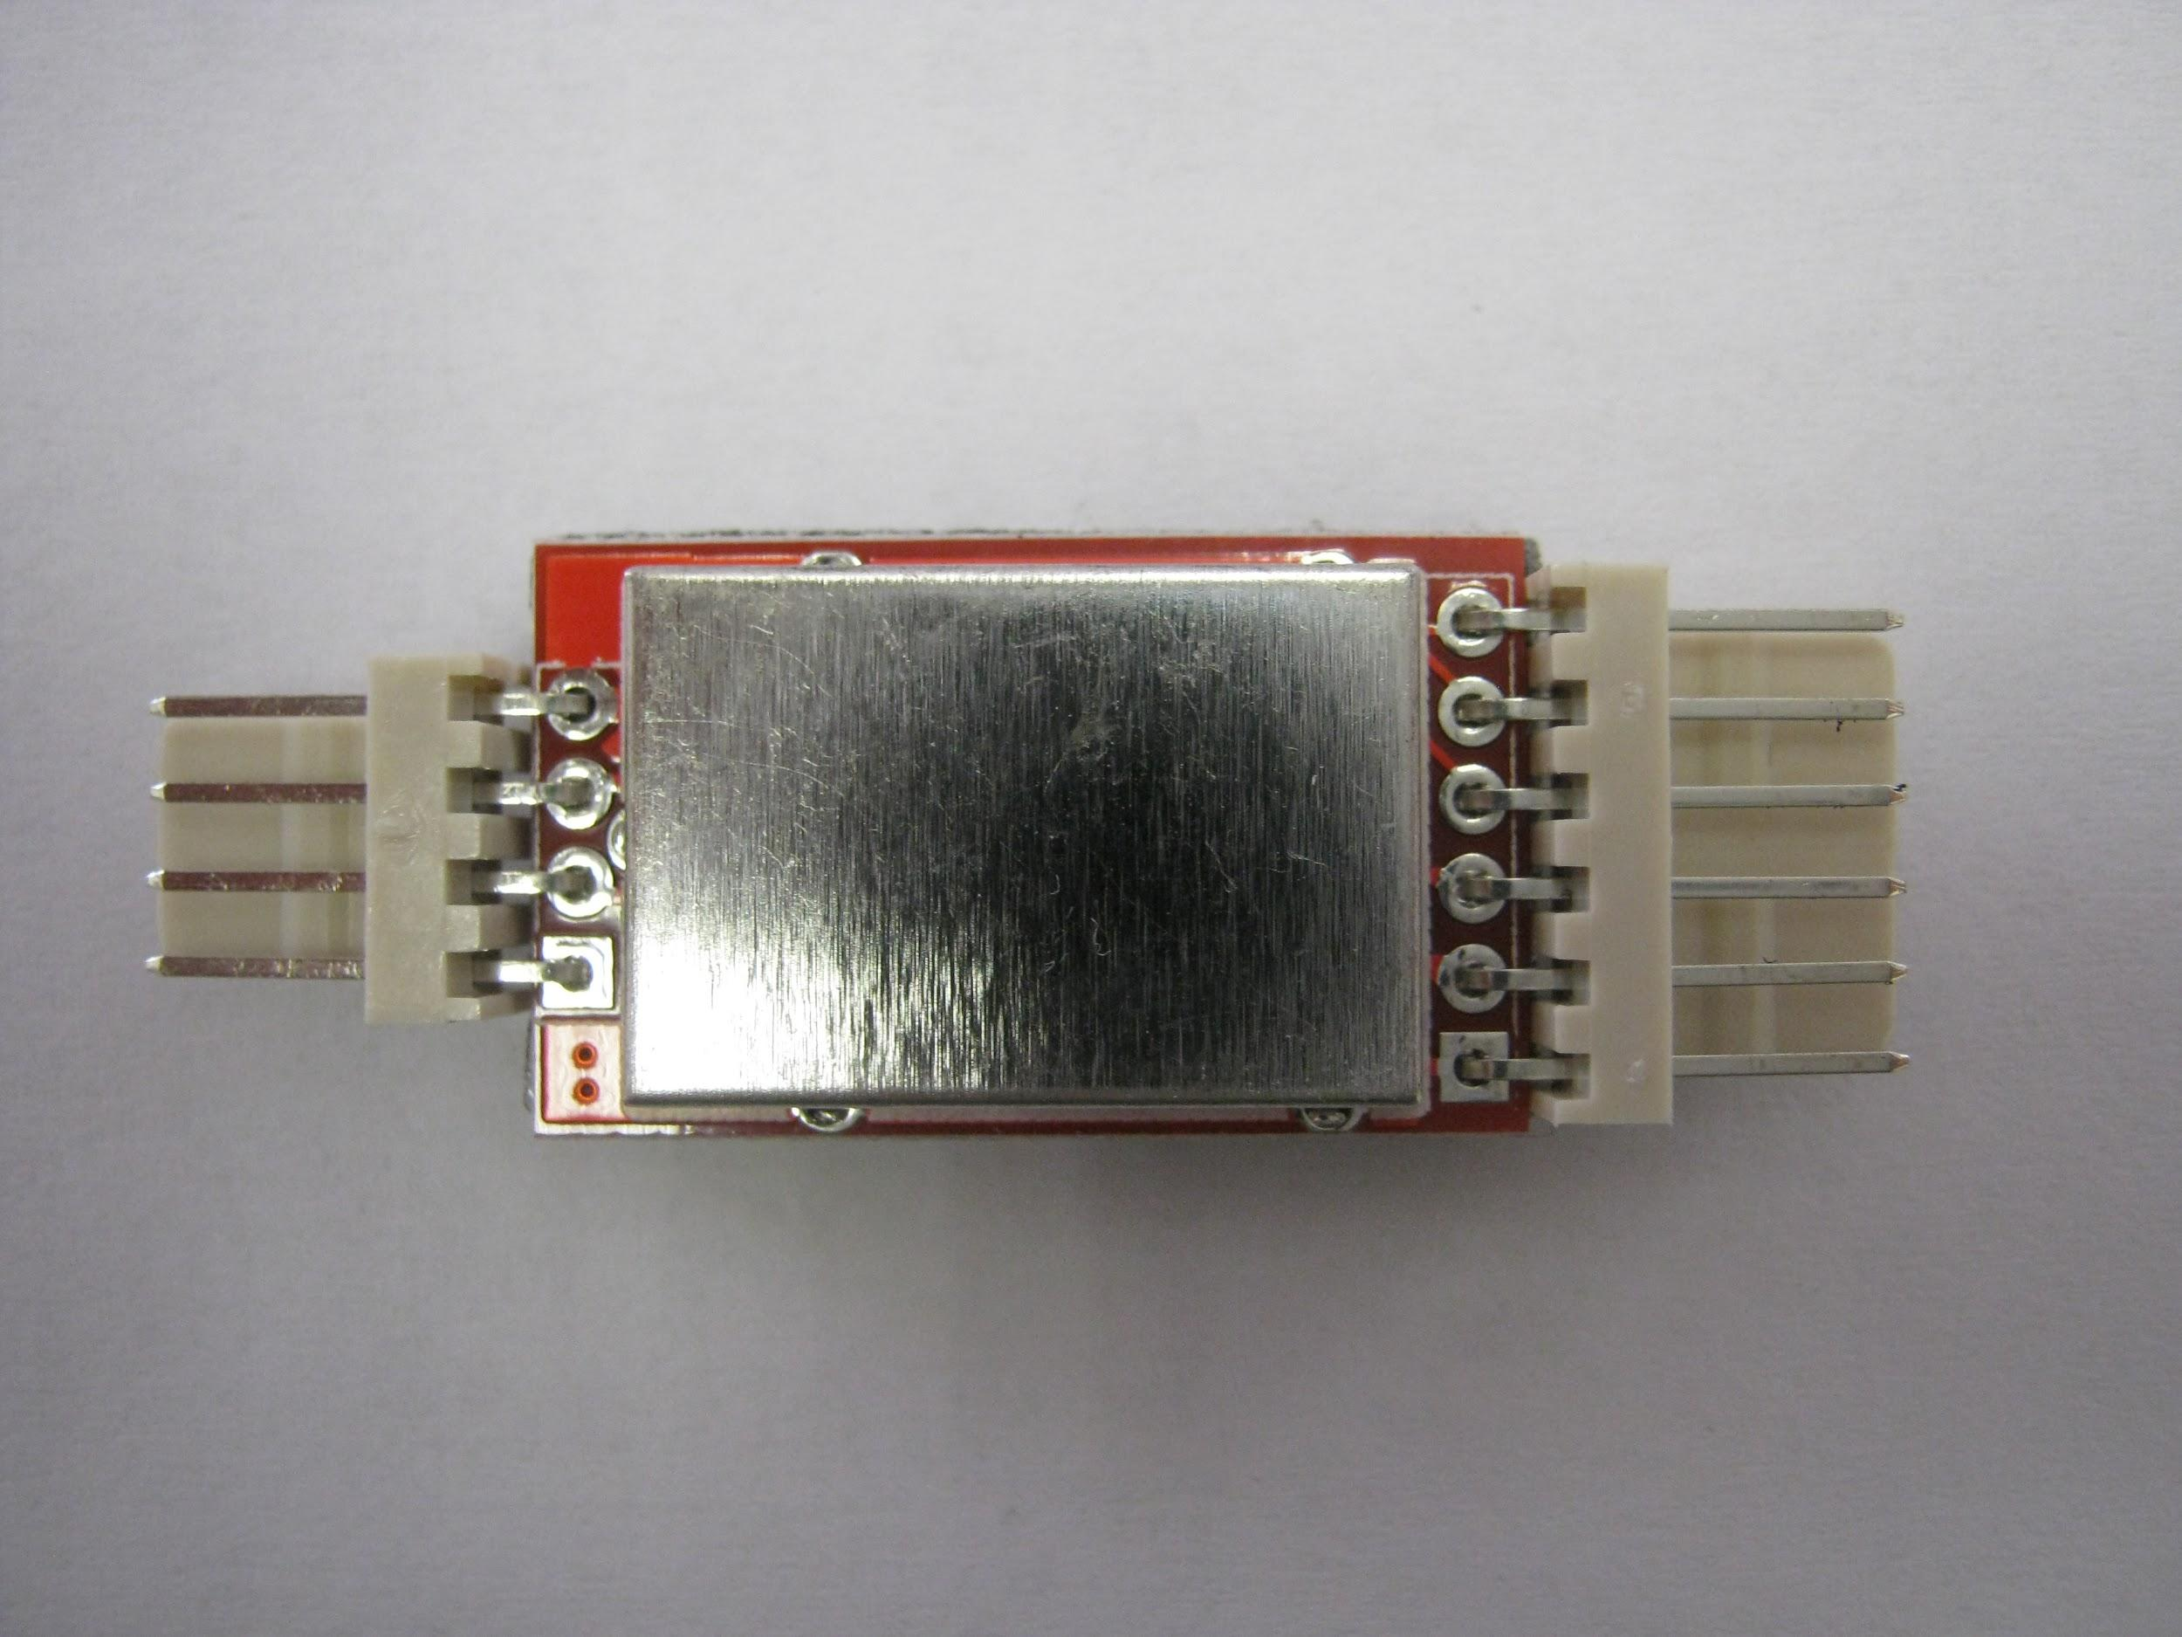

You can mount the new PCBA with a double-sided tape instead of screws. The double-sided tape is already mounted to the PCBA. For this operation you have to remove the old plastic hexagon washers.

Reassemble consists of the same steps in reverse.

At reassembling, make sure you put back the two heat insulations.



Make sure that the wort outlet hose clamp is in the proper angle. Otherwise you cannot reassemble the lower sheetmetal.

